According to the Federal Register Annual Update of HHS Poverty Guidelines, for 2023, the poverty guidelines for Massachusetts are

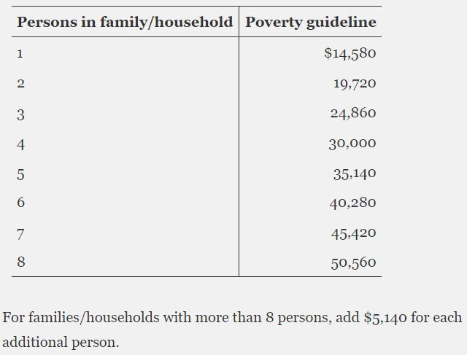

The increase is constant between persons in the family; as the household size increases by one, the poverty guideline increases by **$5,140**.

According to the US Census Bureau, the maximum amount of income a person can make and still be considered under the poverty line as of 2022 is **$64,815** USD, in a family size of nine with no children.

For individuals and families of two, whether they meet the threshold for poverty is determined by the age group of the householder. Individuals under 65 must make less than **$15,225** to be considered under the poverty line, while individuals over 65 have a slightly lower income at **$14,036.**

The poverty level increases as the number of people in the family increases. However, the increase is not linear as the number of children increases, and there exist fluctuations between different household sizes.

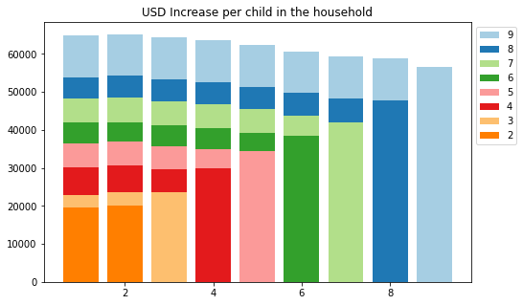

The legend indicates the number of people in the family, while the x-axis indicates the number of children in the household. The y-axis indicates the income required to be at the poverty threshold in USD.

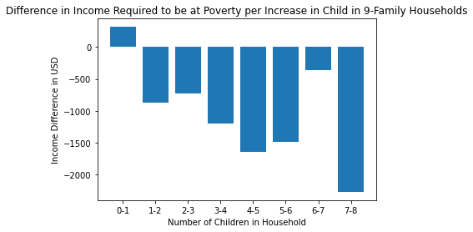

As the number of children in the household increases, the difference between the amount of income required to meet poverty level standards decreases, with the exception of the difference between households with 6 and 7 children.

*Note:* An example on how to interpret this graph: The first bar represents the difference between income levels of households with no children and one child.

Poverty level income of households of 9 people with no children: 64,815

Poverty level income of households of 9 people with one child: 65,129

65,129 - 64,815 = 314.

Thus, as the number of children in 9 people households increase from 0 to 1, the income level required to be considered at the poverty line increases by 314.

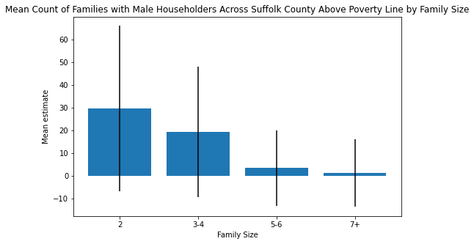

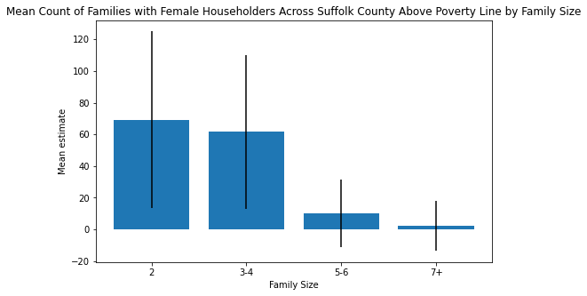

Above is the mean count of families in Suffolk City under the poverty line by family size for male householders vs female householders. Notice the difference in scale– there is a greater number of families with female householders under the poverty line than there is with male householders.

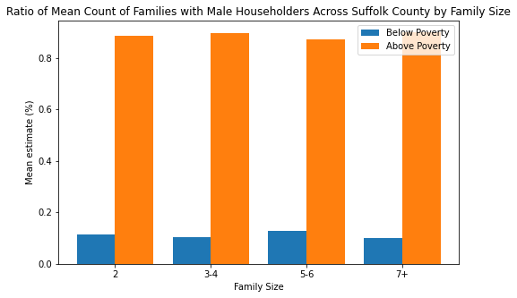

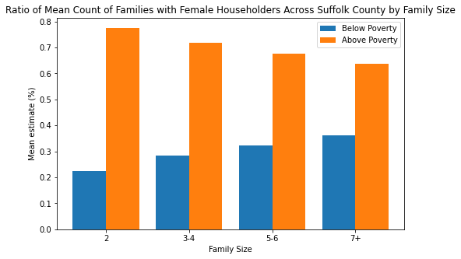

The overall ratio of families with a female head of house below poverty to all families with female head of house is also noticeably higher than families with male head of house.

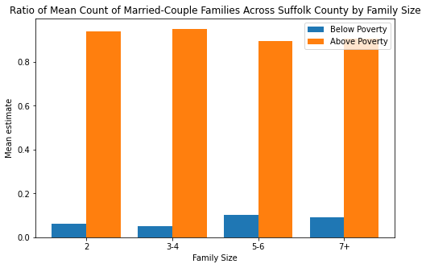

Approximately 5-10% of families in Suffolk County are below the poverty line.

Some final notes:

* There tend to be higher counts of smaller-sized (2-4 people) families under the poverty line in Suffolk County, while larger families are rarer.
* The count of families with female householders (no spouse) living under the poverty line tend to be higher, while families with male householders (no spouse) living under the poverty line tend to be rarer.
* The ratio between married couple and male householder families above and below the poverty line is much greater than female householder families.

Data limitations:

* The census data covers all of Suffolk County, which means the distribution of family demographics may look different for only Boston.
* The data visualization above may not be representative of the population of Suffolk County as there is a lot of missing data, and thus a high margin of error.
* Many of the columns which do not have adequate data have been filled in with zeros, which may have brought down the overall average.
* This data does not take into account percentages, so the ratio of family households of a specific size under poverty to all family households living in the tract may be different.